Online Test Application

Write Up

DESCRIPTION

The Online Test Application system creates an application that enables users to provide online tests, review them, and display the results.

**System Details:**

This system contains three main modules: Quiz, Review, and Result. The quiz section of the online test application accepts the questions in JSON format. The JSON file can be easily shared from the server in the pre-defined format. The application renders the test at the client-side.

The “Review and display result” section allows users to declare the results immediately. You can simply call another JSON with the answers in it and evaluate and display the results immediately...

This document contains contents for:

* Project Description
* Sprint planning
* Flow of the Application
* Core concepts used in project
* Conclusions

**1.Project Description:**

* The Online Test Application system creates an application that enables users to provide online tests, review them, and display the results.
* This system contains three main modules: Quiz, Review, and Result. The quiz section of the online test application accepts the questions in JSON format.
* The JSON file can be easily shared from the server in the pre-defined format. The application renders the test at the client-side.  
  The “Review and display result” section allows users to declare the results immediately.
* You can simply call another JSON with the answers in it and evaluate and display the results immediately.

**2.Sprints planning:**

The project is planned to be completed in 2 sprints.

Tasks assumed to be completed in the sprint are:

· Creating the flow of the application

· Initialising git repository to track changes as development progresses.

· Writing the Java program to fulfil the requirements of the project.

· Testing the Java program with different kinds of User input

· Pushing code to GitHub

· Creating this specification document highlighting application capabilities, appearance, and user interactions.

**3.Application Flow:**

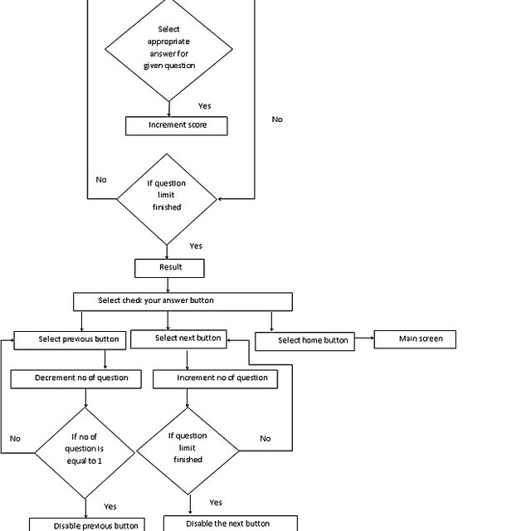

**4.Core concepts used in project:**

* Html
* CSS
* Angular
* Bootstrap
* JSON

**5.Conclusions:**

This project is designed to create an online test application in JSON Format using angular/bootstrap.